**Scheduling via PDM**

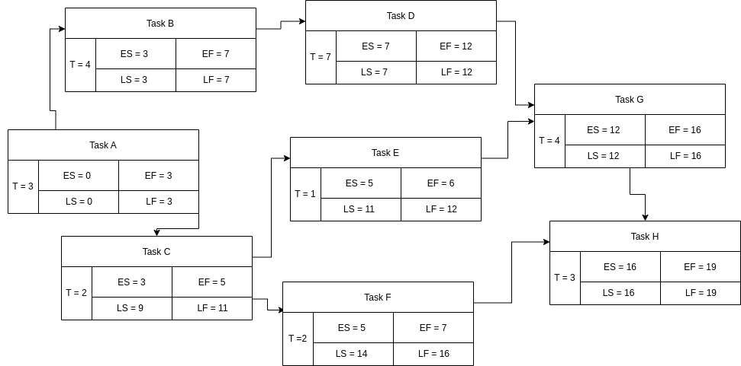

* Early Finish = 16 days
* Late Finish = 19 days